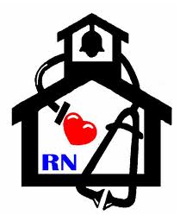
Nurse’s Nook
Pearl Lower Elementary – September
Aly Weems, School Nurse
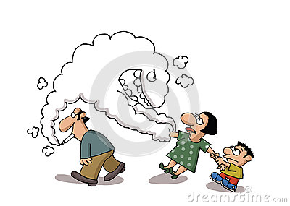 Secondhand Smoke 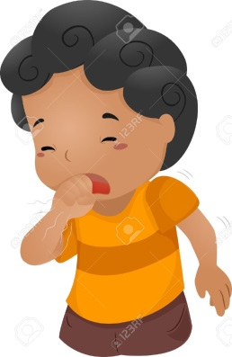
What is Secondhand Smoke? It is the smoke that smokers breathe out. It’s also the smoke from the end of a burning cigarette, cigar or pipe. Burning tobacco puts thousands of chemicals into the air. When nonsmokers breathe secondhand smoke these chemicals go into their bodies.
Why is this dangerous? The chemicals in secondhand smoke can make people sick. Secondhand smoke can make blood vessels narrow and hard. It can make blood thicken and clot. Then the blood can’t carry oxygen to the heart. This can damage the heart and cause a heart attack. Secondhand smoke can increase the risk of getting lung cancer and nose cancer. Children who breathe secondhand smoke can develop asthma. Or their asthma attacks can happen more often and be worse. Asthma causes lung damage and can be life threatening.
Secondhand Smoke and Kids Before age 10, children’s bodies are not fully grown. They have an even harder time fighting the harmful effects of secondhand smoke. Secondhand smoke causes bronchitis, pneumonia, and other lung diseases in children. It causes asthma and/or worsens asthma. It sends thousands of children to the hospital each year with serious lung infections and asthma. Children who breathe secondhand smoke miss more school. It increases ear infections. It can harm an unborn baby and newborn babies.
Protect Yourself, Your Family, and Others 1) Eat in smoke-free restaurants. 2) Ask for a smoke-free work area. 3) Help people who are trying to quit smoking. 4) Support laws that limit secondhand smoke. 5) Never smoke around children or pregnant women. 6) Don’t smoke in a closed car or room with other people. 7) Try to quit!
- If you or a loved one needs help quitting, you can call 1-800-QUITNOW or 1-800-784-8699! It’s never too late to quit!

